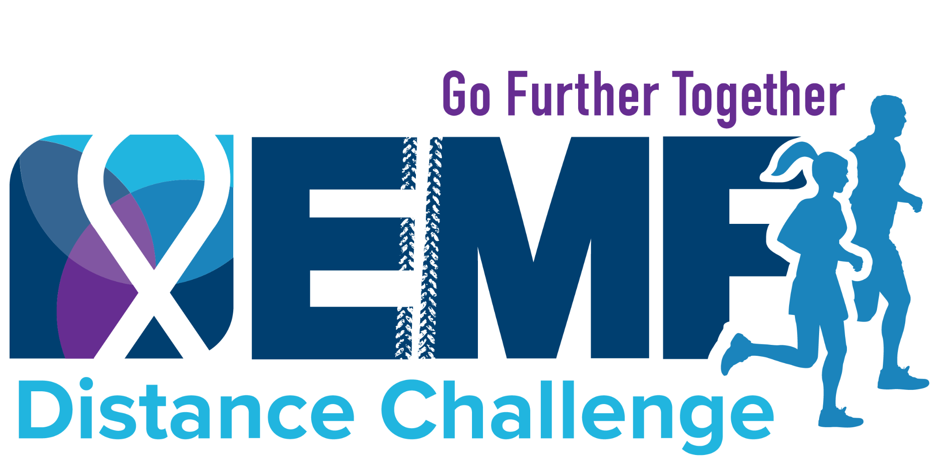

Subject: Join My Team for the EMF Distance Challenge

Hello [Recipient's Name],

Join me for Expect Miracles Foundation’s 2026 Distance Challenge, happening virtually from May 12-19. I'm inviting you to be part of my team. Together, we can make a meaningful impact in the cancer community and have fun along the way.

As a participant, you can pick your activity - run, walk, bike, or choose any activity that gets you moving. Set your own mileage and fundraising goals to make it a personalized and exciting challenge.

This event isn't just about getting active; it's an opportunity to support innovative cancer research and young adult cancer survivors. Let's enhance our well-being while making a positive impact in the cancer community.

This cause is close to my heart. This year, I'm dedicating my efforts to [insert name of someone impacted by cancer who inspires you].

Let's create a better today and a brighter tomorrow together.

Get started and join my team by clicking the “Join Us” button on this page: [insert link to your team page]

Best,

[Your Name]

