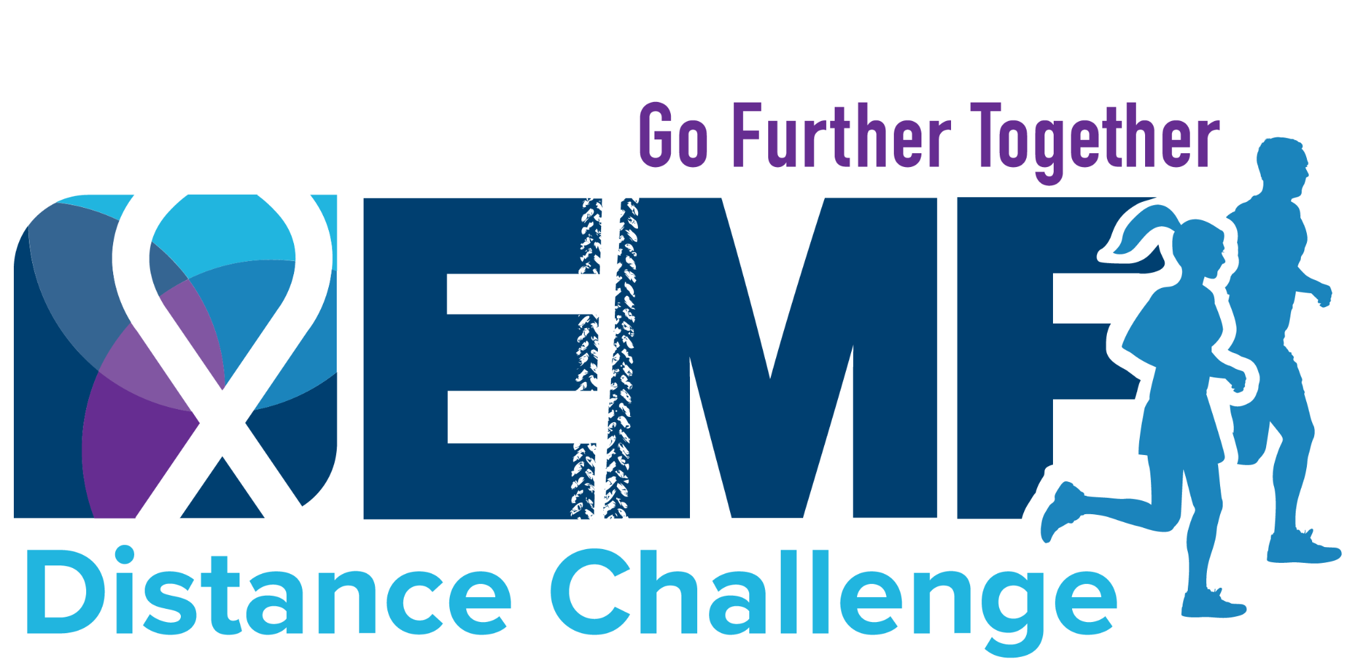

Subject: Join My Cabinet for the EMF Distance Challenge

Hello [Recipient's Name],

I’m putting together a small group of leaders to help power our team for Expect Miracles Foundation’s 2026 Distance Challenge, happening May 12 to 19, and I’d love for you to be part of it.

This year, we’re building a “Team Cabinet” which is a core group of supporters who help drive participation, energy, and excitement across the team. Think of it as an inner circle that helps make everything more impactful and more fun.

As part of the Cabinet, you would:
- Serve as a point person within your department or network
- Encourage colleagues to join and participate
- Share updates, reminders, and key information
- Help build momentum leading up to and during the event

There’s no experience needed, just a willingness to motivate others, build community, and support a meaningful cause.

The Distance Challenge is a virtual event where participants can run, walk, bike, or choose any activity, set their own goals, and raise funds to support cancer research and young adult cancer survivors.

Would you be willing to join our team Cabinet and help lead our team? Let me know by responding to this email and joining the team here: [insert link]

Once we let Expect Miracles Foundation know that you are part of the cabinet, they will mark you as a “Team Captain” on our team page.

Thank you for considering it. It would mean a lot to have you in this leadership group.

Best,
[Your Name]

