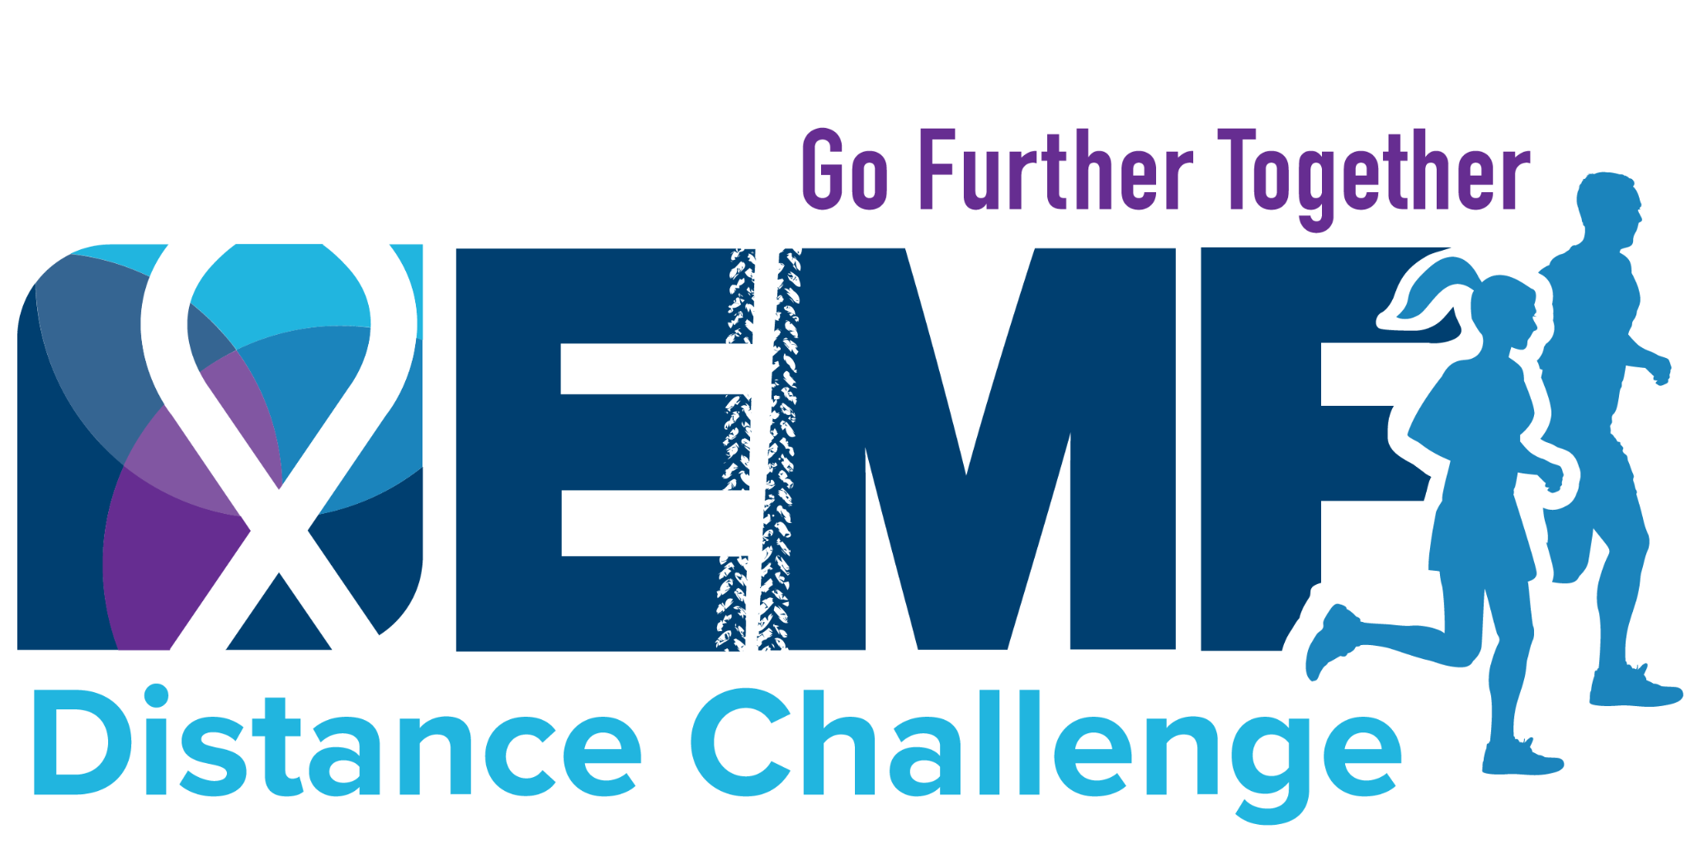

Subject Line: Support My EMF Distance Challenge | Leave Cancer Behind

Dear [Contact's Name],

This May, I'm getting moving to leave cancer behind with the Expect Miracles Foundation's [EMF] Distance Challenge. Can I count on you to donate and support my fundraising efforts?

EMF directs funds to groundbreaking cancer research at Dana-Farber Cancer Institute and Memorial Sloan Kettering Cancer Center while providing essential financial grants to young adult cancer survivors. Thanks to the generosity of EMF’s sponsors, 100% of your donation goes directly to the cause.

I've set a goal to raise $______, and your support is key to reaching it.

Please consider donating to my fundraising campaign here, [insert link to your fundraising page].

Any contribution, big or small, makes a significant impact. Your support means the world to me, and to those impacted by cancer.

Optional: share your personal connection with the cancer community and how it is motivating you to go the distance in 2026.

Your support and any donation, no matter the size, will fuel my Distance Challenge journey. Every bit counts.

Thank you!

Sincerely,

[Your Name]

